DOCUMENTATION

**Grocery: Solution for your daily need**

Welcome to Grocery, the one-stop solution for all your grocery shopping needs! Whether you're looking for fresh produce, pantry essentials, or household items, Grocery has got you covered. This documentation will guide you through the app's features and functionalities, making your grocery shopping experience seamless and enjoyable.

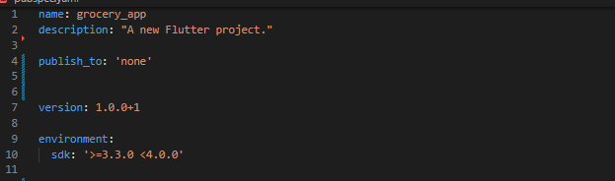

→ **Text used:**  Montserrat from google fonts.

**→ Primary color: Color.fromARGB(255, 50, 227, 56).**

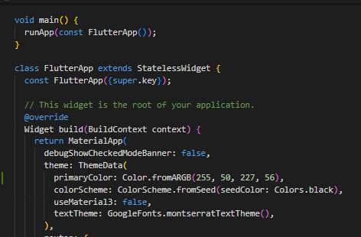

**→ NOTE:** These two are declared in the main file, so that it can be changed from there for the whole file.

**Packages used:**

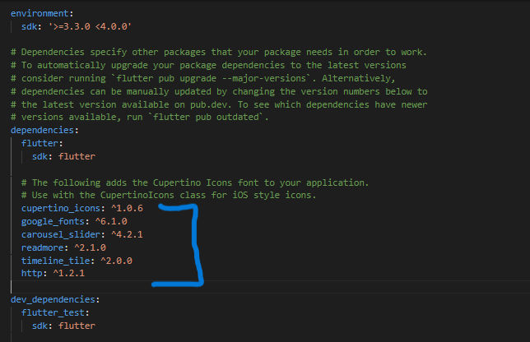

**1. Cupertino icons:**

→ The Cupertino Icons are available as a package in Flutter, making it easy for developers to integrate them into their Flutter applications for ios.

cupertino_icons: ^1.0.6

import 'package:flutter/cupertino.dart';

**2.Google fonts:**

→ The "google_fonts" package is a popular choice for integrating Google Fonts into Flutter applications.

google_fonts: ^6.1.0

import 'package:google_fonts/google_fonts.dart';

**3.carousel slider:**

→ The carousel_slider package provides a convenient way to incorporate carousel sliders into your Flutter applications, making it easy to create dynamic and interactive user interfaces.

carousel_slider: ^4.2.1

importpackage:carousel_slider/carousel_slider.dart'

**4.readmore:**

→ "Read More" functionality for displaying long texts with the option to expand or collapse them.

readmore: ^2.1.0

import 'package:read more/read more.dart';

**5.Time line tile:**

→ you can create visually appealing timeline components for your Flutter applications, suitable for displaying chronological events or data.

timeline_tile: ^2.0.0

**6.Http:**

→ The http package in Flutter is widely used for interacting with RESTful APIs and fetching data from web servers in Flutter applications.

http: ^1.2.1

import 'package:timeline_tile/timeline_tile.dart';

**1. Splash screen:**

Upon launching the app, users are greeted with the **Grocery logo and name,** setting the tone for a convenient and user-friendly shopping experience.

**2. Sign up:**

The Sign Up page allows new users to create an account with Grocery.

Fields:

→ Firstly here is an asset image put together using **stack**. Over it there are the texts.

→ After it there is a **card,** in it there is a heading for it.

→ Following it there are text fields in which the user will add the information below.

→ **Email:** Users input their email address.

→ **Password:** Users create a password for their account.

→ **Confirm Password:** Users re-enter their chosen password for confirmation.

→ **Text Button:** This button here is to go on the sign in page if you already have an account.

→ Which says already have an account, which means that if the user already has an account that by tapping it they can directly go on the sign on page which is routed on the on tap function of it.

→ **Submit Button:** Once all required fields are filled, users can submit their information to create their account. This button is an **elevated button.**

**3. Sign in:**

The Sign In page is designed for existing users to access their Grocery account.

Fields:

→ This page is quite similar to the above one, but here there are only two text fields for email and password.

→ **Email:** Users input the email associated with their account.

→ **Password:** Users enter their password.

→ After that there are two text buttons put together under a row. One of them forgot password and the other one is new here.

→ **Submit Button:** After entering valid credentials, users can sign in to their account.

**→ Forgot Password:**

Users who forget their password can request a password reset.

By clicking on the **"Forgot Password"** link on the Sign In page, users can initiate the password reset process.

An email will be sent to the registered email address with instructions on resetting the password.

Let's take a tour of the features available on the Home Screen:

**4. Home Screen:**

**App Bar:**

The **App Bar** features the Grocery **logo and a cart icon** for quick access to your shopping cart.

**Main Scaffold:**

**Carousel Slider:** Swipe through enticing images showcasing featured products and promotions, providing a visually engaging shopping experience.

Drawer Icon: Located in the App Bar, tapping on this icon opens the Navigation Drawer for easy access to additional functionalities.

**Navigation Drawer:**

→ **User Information:** Displays the user's name and email address for personalization.

Options:

→**5**.**Profile**: Edit personal information, view order history, and manage account settings.

**–** in this page you find an app bar with the icon,

**( Icon(Icons.arrow_back_ios_new))**

And the two two texts, which are profile and edit profile which are put together in using row.

– One of the texts in a row is for the Edit profile page to edit the user's profile.

**6.Edit profile:**

→ This page is made for the user to edit the profile.

→ first there is a heading and following it there is a section to add a profile photo or change the profile photo.

→ After that there are 4 **text fields** to edit the name, email, mobile number and gender of the user.

→ At last there is an elevated button to save the information which is edited.

**–** after that there is a section for the photo of the user.

**–** The following are 4 **text form fields** that contain name,email,mobile number and gender. Users can fill the information according to them.

**–** There are 4 containers that have 4 categories: my orders, favorites, addresses and my reviews. Each has 4 different pages **routed** using **if- else statements.** It is routed under the inkwell widget. So if the user taps it, they will visit a new page routed in it.

– These 4 pages are: 1) My orders.

2) Favourites.

3) addresses.

4) My reviews.

**7. My orders:**

→ This screen is to take a note on ordered products and to track them.

→ firstly it has a heading with the icon.

→ after that there is a search box created with the container and a row in it’s child property which includes a search icon and text.

→ after that there is an asset image following the search box. The image is “**filter box.png”.**

→ The image is wrapped with an inkwell and in the on tap function of the inkwell there is a “**show bottom sheet** ” widget which returns a container for order status and price range.

→ following the search box there are some cards which show the image of the product, delivery date, product information and the text button called “Rate product”.

→ There is a widget created for these cards which is named **“rate products widget”.**  Which are called here.

**8.Favorites:**

→ This page is for the products you have added to your favorites.

→ here also is a heading there and following is the search box just like the page before this.

→ here the cards are just like the my orders page but these have the favorite icon in the left corner.

→ For this also there is a widget created called **“fav products”.**

→ so the widget is called here.

**9.Addresses:**

→ this page is for the addresses.

→ explanation given in the drawer part.

**10.My reviews:**

→ This page is made for the **reviews** given to the product.

→ firstly it has the heading with **icon and text.**

→ after that there is a container which has an image of the product which is an **asset image, name of the product and price.**

→ In this container there is another container also with the primary color.

→ It contains information like the user's name,the stars he gave and the review.

→ There is a widget created for this whole container, named **“Review sheet”.** Which is directly called here.

→ **11.Categories page:** Explore a variety of product categories for convenient browsing.

**–** This screen firstly has the icon, **( Icon(Icons.arrow_back_ios_new))**

And a text “categories”.

**–** After that there is a search box which is made using a **container**, in it there is a search icon and a text “search here” put together using a row.

**–** and the following is that the widget made for the cards is used to display the different categories.

→ **Search product:**There is a widget created for the whole card in the widgets section called **“product card list”** used in this page. which is called into the search product section into the drawer. Which opens up the product list page.

– This page is made to search for the products you want with the image, price and other information about this page.

→ **12.My Cart(cart page) :** Access and manage items added to your shopping cart. Review, edit, or proceed to checkout.

– In this option there is a page called **“cart page”** is routed.

– This page here firstly contains the heading and the discount icon is there which is an asset image **“circle icon.png”.**

– In the image there is a code snippet returned using the **“show modal bottom sheet widget”** . which contains the discount coupons. So if the user taps on it, the bottom sheet opens up there because the inkwell wrapped around it contains the bottom sheet.

– After that there is a card which has information about items: **image, name, price, discount price, short information,and a symbol of a vegetarian item**. All of these are put together using **stack.**

– after that there is a **container** which shows the discount contained and the coupon applied.

– following that there is a container which is for **shipping address**, the name of the customer and mobile number. There is a text button right there in the right corner which opens up the page to change address.

–**13**. **Saved addresses page:**

→ This page first has the heading with the icon and text. In the same row there is a **Text button** to add a new address if you want to add a new address.

→ Below this, there are the addresses added before. You can select amongst them.

– **14.Add addresses page:**

→ This page also has a heading first with the icon and a text.

→ there are many text form fields here to fill all the information regarding the address you want to add: full name, email, contact number, alternate number, house number, address, state, district,city,pin code etc.

→ There are two selective options for home and office address, both are **elevated buttons.**

→ there is a last option of add address to add the address to the saved addresses. This is also an elevated button with icons and text in a row. In the on tap of this button, the **saved addresses** page is routed.

– After that there is a container which shows the total price details of the products you want to buy.

– There is an elevated button used in the last to process all the details and takes the user to the pricing page. So the payment page is routed in the on pressed function of that button.

**15.Payment page:**

The payment page is for the payment options. It gives the user an option to pay for the products.

→ in the beginning there is a heading for it and after that there is a container which has **7 payment options**:

1. Credit card/ debit card
2. UPI
3. Net banking
4. Wallets
5. PayTm
6. Google pay
7. phonePe

→ In the first **4 options**, there is a row and in it first there is an **asset image** or the **icon** for a particular option then there is a text and in the last there is an asset image of an arrow for the selected option.

→ each row is divided by a **divider.**

→ after the 4 rows, there are **3 containers** in the row which contain the asset image of the other three options.

→ each row is covered with an **inkwell.**

→ **Support**: Get assistance from customer support. Contact options include live chat, email, and FAQ.

→ **Logout Icon:** A circular icon positioned at the bottom of the Navigation Drawer allows users to securely log out of their account.

**Categories Section:**

After the Carousel Slider, the Categories Section is prominently featured, inviting users to explore various product categories.

**Layout:**

→**Cards Display:** Categories are presented in a visually appealing manner, with three **cards** displayed in a row **horizontally.**

→ **Asset Images:** Each card features an asset image representing the category, providing users with a visual cue of what to expect.

→ **View All Button:** Positioned below the row of cards, a text button labeled "View All" encourages users to explore all available categories.

**Interaction:**

View All Button: By clicking on the **"View All"** button, users are directed to the comprehensive Category Page, where they can browse through an extensive list of categories and subcategories.

**Categories:**

Upon clicking "View All," users are seamlessly transitioned to the Category Page, which offers an extensive collection of categories and subcategories.

Users can navigate through categories, view product listings, and add items to their cart with ease.

**Products for you section:**

After the category section there is a section called products for you section which shows the user products which are related to their searches or the recent searches.

→ This section includes the usage of **list-view builder**, the cards that are shown here are put together with the use of listview builder.

→ Every other element in the main card is used by using **stack**.

→ The card here has the combination of **text, asset image and buttons** put together one by one.

→ The buttons which are used here are **Elevated buttons**. The first button is the cart button, by clicking on it we can see the cart page. And the other button is buy now button, if someone wants to buy that product they can click on it and can do further processing.

→ the whole column in the container is wrapped by **inkwell** and the **product details page** is routed in the on tap function of it.So when you click on the image or any other area except the buttons, the product details page opens up.

**Popular categories:**

→ After the products for you section there is a section called popular categories, in which all the popular categories which are available in the particular section are shown.

→ the whole section is made by using a **container, media query and stack.**

→ where another container and an asset image is used under a stack.

→ There is a widget made of this whole container in the widgets folder called **“Category card”** which is called in the homepage.

**16.Product details screen:**

→ The product details page is made for the detailed information of the particular product.

→ If a user wants to check the details of the product they can access it from this page.

→ The background color of the scaffold is in the shade of,

**Color.fromARGB(255, 213, 204, 204),**

→ Whole page is created by using stack and for sizing we used a **media query** here by declaring variables for height and width.

→ first element in the scaffold is the back button

**( Icon(Icons.arrow_back_ios_new))**

→ Which is covered by an **inkwell** and in the on tap function of it we routed **homescreen** to get quickly back on the homescreen.

→ After that there is an image of the product and the button to add the product to the favorite product.

→ On the right below of the image there is a container which has the information of the product in the form of read more and show less.

→ for it we used the **“ReadMoreText”**widget.

→In the end we used two buttons which are **elevated buttons**. One of them is to add items to the cart and the other one is to buy items now.

→ for rating the product, there is an option near the name of the product, which is “Rate product”. It is a text button and in its on pressed function there is a widget which is **“Show modal bottom sheet”** and in it we return a container for rating the product.

→ This container first has the name **“Rate product”** and under it there is a divider.

→ After that there are 5 icons, from which 4 are **Icons. Star_rounded.**

→ The last one is **Icons. Star_rounded_outlined.**

→ Following that there is a textfield created under a container for the verbal reviews.

→ At last there is a button to submit it, the button is created with a container and an asset image in it.

**17.Support Page:**

→ This page is made for customer support.

→ There are **5 options** given to the user to submit their issues by categories.

→ options:

1. Report a bug
2. Submit feedback
3. Technical issue
4. Product or order related issue
5. Payment related problem

→ These 5 options are in the format of a radio button, created using the **Radio widget.**

→ For this is a variable declared in the code which is **“selected value”**.this variable is called in the on pressed function of set state property.

→ The active color of the radio button is the primary color as defined

→ After that there is a **textfield** created under a container, to explain the issue of the user in their words in brief.

→ At last, there is an elevated button to submit the information.